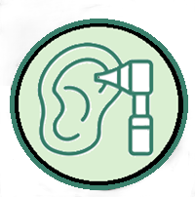
Loud and Clear Mobile Microsuction - Cancellation Policy

Loud and Clear Mobile Microsuction Ltd values your time and appreciates your commitment to your appointments. To ensure fairness to all patients and efficient appointments schedule, we have implemented the following late cancellation and no-show policy.
We understand that the unexpected can occur from time to time, and where possible we will endeavour to accommodate any changes to your scheduled appointment.
However, we kindly ask all clients to provide as much notice as possible if they need to cancel or reschedule an appointment.
Cancellations made with less than 1 hour’s notice will incur the full appointment fee of £50.
If you need to cancel or reschedule your appointment, you can do this via Setmore on our websites booking page, alternatively you can call or message us directly.
Thank you for your understanding and cooperation

